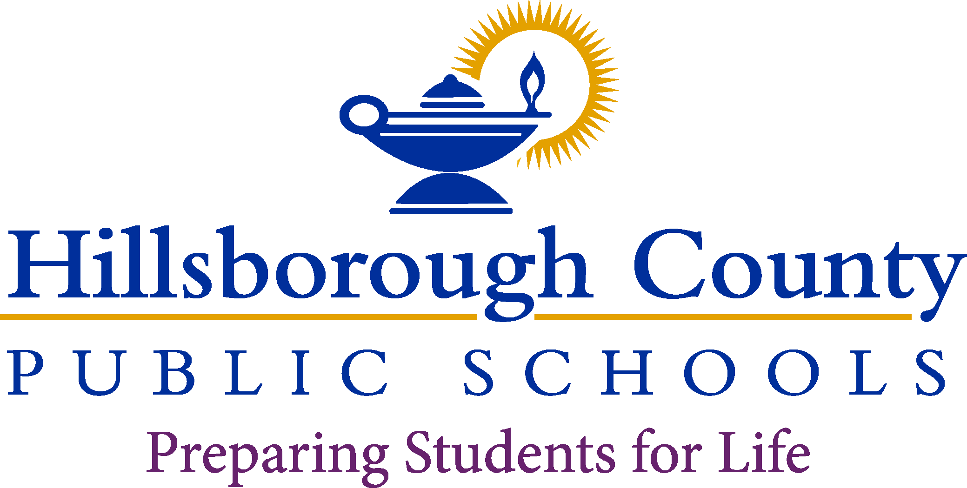

**Interim Superintendent**

Van Ayres

**School Information Here**

**School Board**

Nadia T. Combs, Chair

Henry “Shake” Washington, Vice Chair

Lynn L. Gray

Stacy A. Hahn, Ph.D.

Karen Perez

Patricia “Patti” Rendon

Jessica Vaughn

Date:

Dear Parent or Guardian,

Hillsborough County Public Schools is excited to continue our partnership with Panorama Education. Panorama works with 12 state agencies, 1,500 districts and 21,000 schools in all 50 states to collect and act on stakeholder voice, supporting over 15 million students. With a focus on student wellbeing, Panorama partners with districts to build supports for all learners.

By continuing to work with Panorama, our district will continue to have access to a powerful online platform to help us share and act on data. We are excited to provide our educators and schools with a research-backed survey to support student wellbeing and academic needs.

The Fall survey window will begin October 2, 2023, and close on October 27, 2023. All students in grades 4-12 will be asked to participate in the survey. The survey will ask students to self-reflect on their social skills, school climate and culture, and sense of belonging. You can preview the survey content by clicking [here for grades 4-5](https://admin.panoramaed.com/hcps/survey/demo_templates/122369?administration_id=74676&term_id=0) and [here for grades 6-12](https://admin.panoramaed.com/hcps/survey/demo_templates/122368?administration_id=74676&term_id=0) or scanning the QR codes at the bottom of this letter.

The Panorama platform will also include an online “Playbook” of lessons for teachers. These lessons will help support our students in the classroom with skills such as goal setting, decision making and conflict resolution.

If you would like your child to opt out of taking the survey please submit [this form](https://docs.google.com/forms/d/e/1FAIpQLSevcha7KNJRDZYBtZiOWCKvR6ARqMuKzJo6aj1-xUPcyQItPQ/closedform), or use the QR code below by **October 1, 2023**. If you have any questions about the survey administration, please do not hesitate to contact (insert administrator or Panorama Coordinator information here)

We are excited to continue our partnership with Panorama Education and look forward to supporting student life skills competencies.

Respectfully,

(Insert School Administrator Signature)

Opt Out 6-12 Survey 6-12 Survey 4-5 Survey 4-5 Survey

